**5G NR and RLC system (ARQ)**

**Slide 1: Title Slide**

* **Simple Explanation**: "Testing 5G’s Data Fixing System Automatically with Robot Framework"
* **What It Means**: We’re building a way to check if 5G can fix lost data fast and properly, all by itself.
* **Visualization**: A big “5G” logo with a robot cartoon holding a checklist, plus your name and date (Feb 26, 2025).

**Slide 2: What is 5G NR and RLC?**

* **Simple Explanation**: 5G is super-fast internet for phones and more. RLC is like a helper that makes sure data gets sent correctly between your phone and the network tower.
* **What It Means**: RLC is a safety net—it catches mistakes and fixes them.
* **Visualization**: A phone sending a message to a tower, with a “safety net” catching falling data packets.

**Slide 3: Project Goal**

* **Simple Explanation**: We want to test if 5G’s “fix-it” system (ARQ) works well—checking timers, data order, and replies (yes/no signals).
* **What It Means**: Make sure lost data gets resent quickly and in the right order.
* 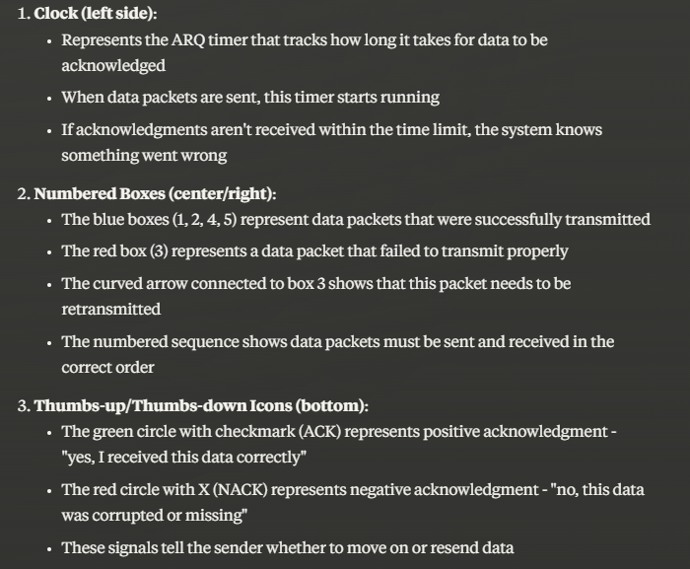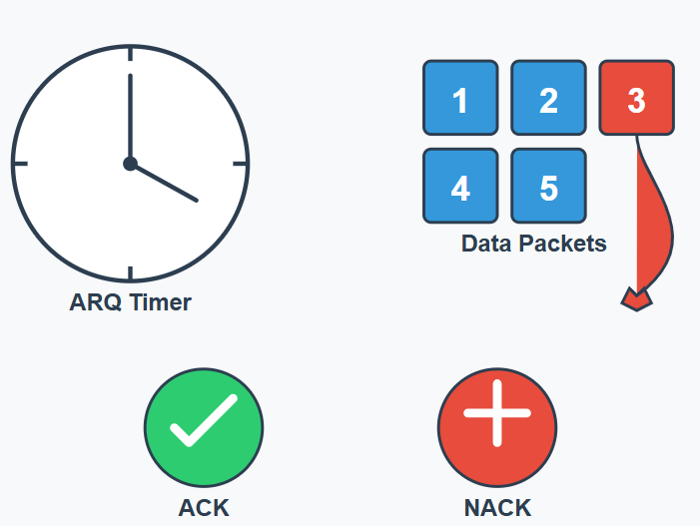**Visualization**: A clock, numbered boxes (data), and a thumbs-up/thumbs-down icon.

**Slide 4: Why Test Automatically?**

* **Simple Explanation**: Doing it by hand takes too long and can miss stuff. A computer does it faster and better.
* **What It Means**: Automation saves time and catches more problems.
* 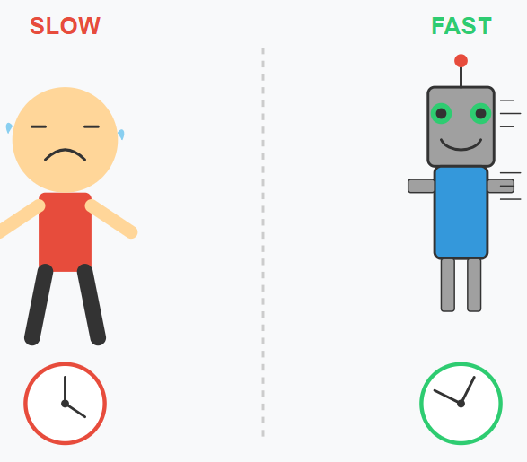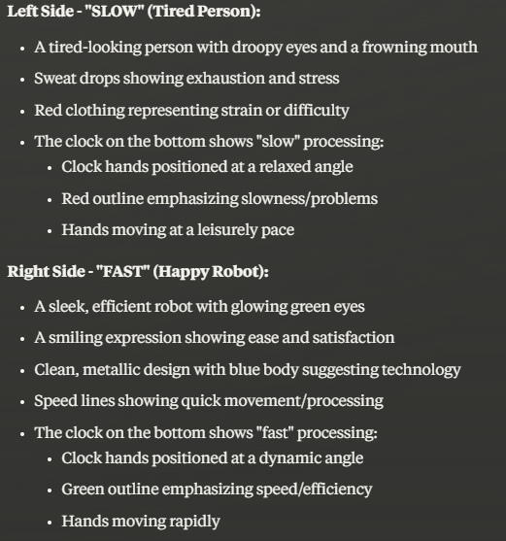**Visualization**: A tired person vs. a happy robot, with a clock showing “slow” vs. “fast.”

**Slide 5: Rules We Follow (3GPP Specs)**

* **Simple Explanation**: These are rulebooks (TS 38.322, etc.) that tell us how 5G should work and how to test it.
* **What It Means**: We’re following the official 5G instructions.
* 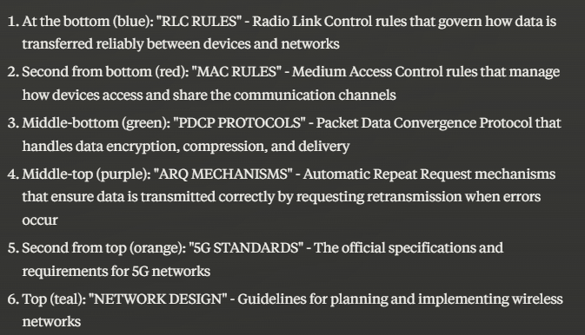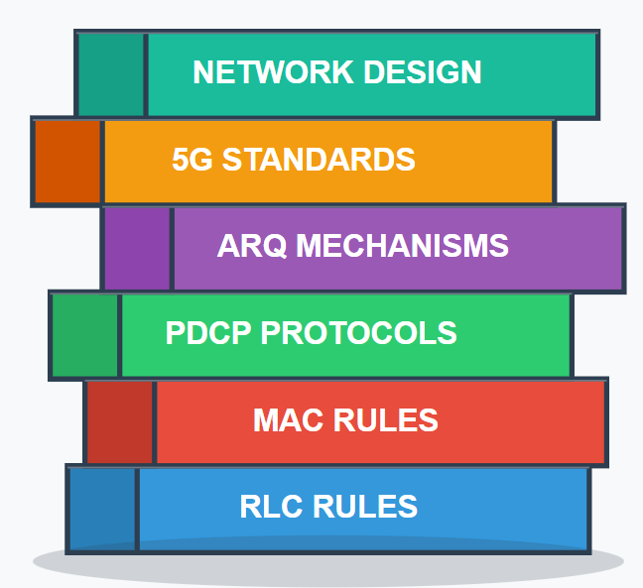**Visualization**: A stack of books with labels like “RLC Rules,” “MAC Rules,” etc.

**Slide 6: What’s ARQ?**

* **Simple Explanation**: ARQ is like a mailman who checks if your letter arrived. If not, he sends it again.
* **What It Means**: It makes sure no data gets lost forever.
* 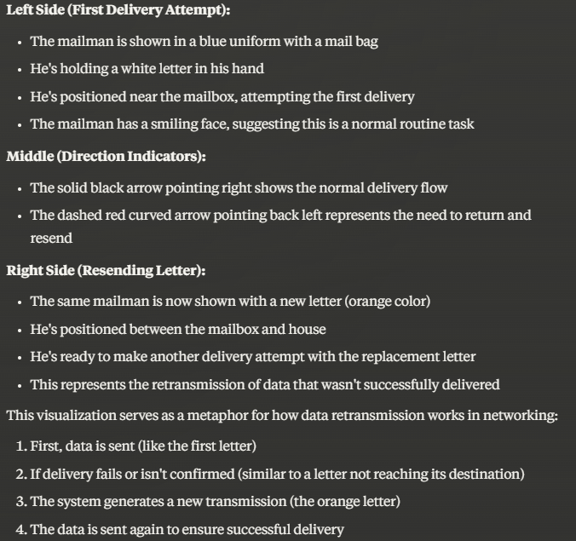**Visualization**: A mailman delivering a letter, then going back to resend it.

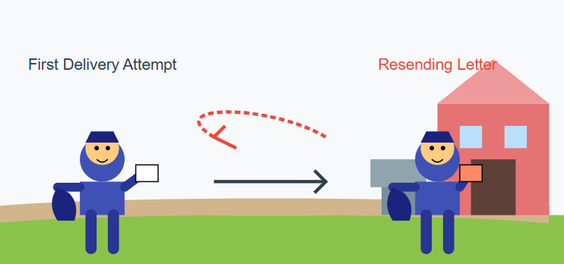

**Slide 7: Test 1 – Basic Resending**

* **Simple Explanation**: Send numbered data (1, 2, 3, 4), lose #3 on purpose, and check if it gets sent again.
* **What It Means**: Make sure the system notices and fixes missing pieces.
* **Visualization**: Four boxes (1, 2, 3, 4), with #3 falling and a hand catching it later.

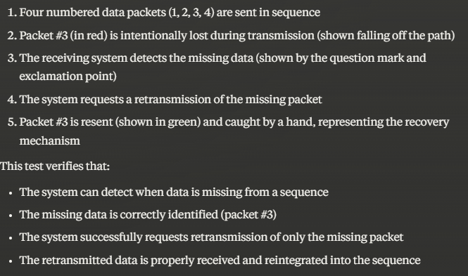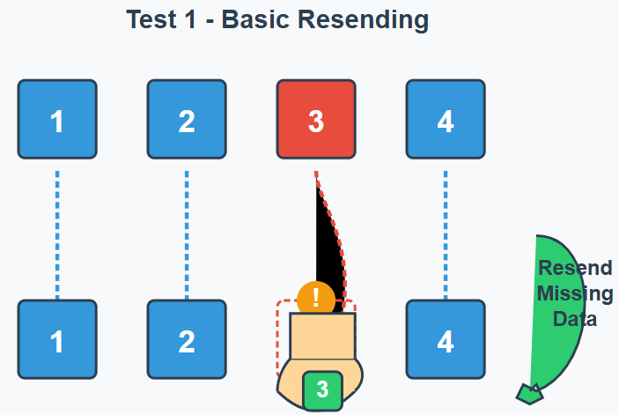

**Slide 8: Test 2 – Timing Check**

* **Simple Explanation**: Change how long the system waits before resending or replying, then see if it’s fast enough.
* **What It Means**: Test if it fixes things on time.
* **Visualization**: A stopwatch with “Wait” and “Go” arrows.

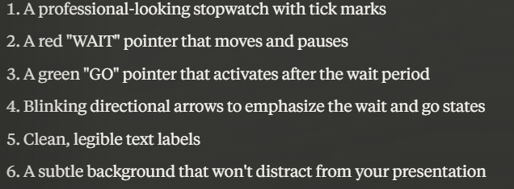

**Slide 9: Test 3 – Speed and Impact**

* **Simple Explanation**: Check how fast data moves with fixes on vs. off, and see the difference.
* **What It Means**: Find out if fixing slows things down too much.
* **Visualization**: A race car with “Fix On” and “Fix Off” labels, showing speed bars.

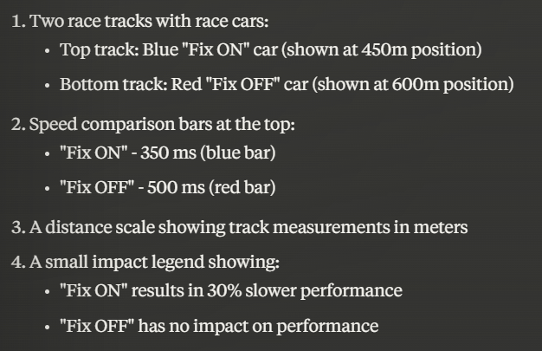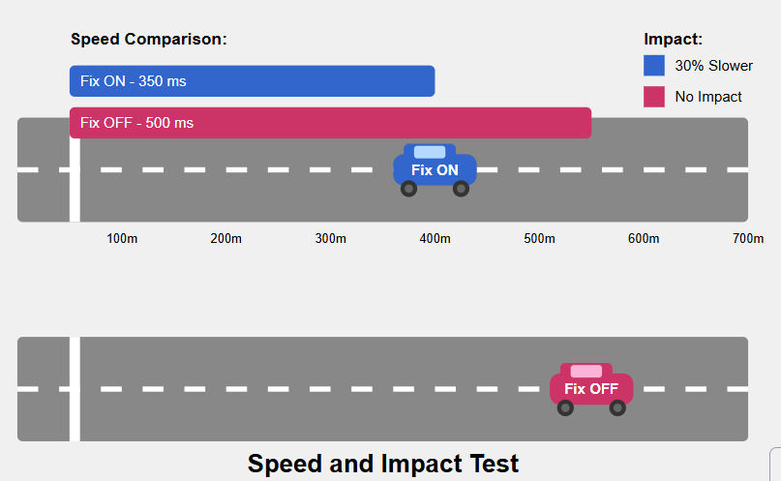

**Slide 10: Test 4 – Stress Test**

* **Simple Explanation**: Send tons of data and lose some to see if the system can handle the pressure.
* **What It Means**: Test if it works when things get crazy.
* **Visualization**: A flood of boxes with some falling, and a robot holding them up.

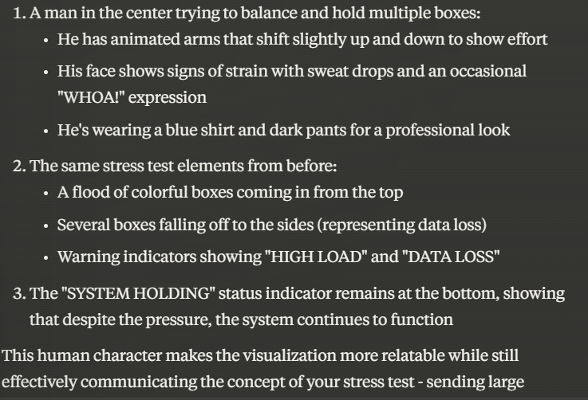

**Slide 11: Tools We Use**

* **Simple Explanation**: We use Robot Framework (a testing tool) and machines like Keysight or Spirent to pretend we’re on a 5G network.
* **What It Means**: These helpers make testing possible.
* **Visualization**: A toolbox with a robot, plus pictures of test machines.

**Slide 12: Real-Life Example – Phone Networks**

* **Simple Explanation**: Big companies like Verizon test 5G to keep calls and videos smooth for millions of people.
* **What It Means**: This stuff keeps your phone working!
* **Visualization**: A map with 5G towers and happy people using phones.

**Slide 13: How We Test – Step 1**

* **Simple Explanation**: Hook up a fake tower and phone, then set it to “fix mode.”
* **What It Means**: Get everything ready to test.
* **Visualization**: A phone and tower connected by a wire.

**Slide 14: How We Test – Step 2**

* **Simple Explanation**: Send data, lose some on purpose, and watch for “yes” or “no” replies.
* **What It Means**: See if the system catches and fixes errors.
* **Visualization**: Data boxes flying, some disappearing, and a “Yes/No” sign popping up.

**Slide 15: How We Test – Step 3**

* **Simple Explanation**: Look at the results in files and make cool charts to show what happened.
* **What It Means**: Turn test info into something easy to understand.
* **Visualization**: A chart with colorful lines (like a heartbeat monitor).

**Slide 16: What We Expect**

* **Simple Explanation**: The system should fix almost all lost data, spot problems, and make a report.
* **What It Means**: Prove it works great!
* **Visualization**: A checklist with green checkmarks and a report page.

**Slide 17: Real-Life Example – Smart Cars**

* **Simple Explanation**: Self-driving cars use 5G to share info fast. ARQ makes sure no data gets lost.
* **What It Means**: Keeps cars safe on the road.
* **Visualization**: A car with “5G” waves and a “safe” bubble around it.

**Slide 18: Problems and Fixes**

* **Simple Explanation**: Busy areas might lose more data, so we adjust timers. Tools might not work together, so we tweak them.
* **What It Means**: Solve hiccups to make it perfect.
* **Visualization**: A city skyline with a “Fix” button, and a puzzle piece fitting in.

**Slide 19: What’s Next?**

* **Simple Explanation**: Test newer 5G stuff, use smart tech to guess problems, and get ready for 6G.
* **What It Means**: Keep improving for the future.
* **Visualization**: A road from “5G” to “6G” with a robot waving ahead.

**Slide 20: Wrap-Up**

* **Simple Explanation**: Auto-testing makes 5G better for videos, games, and cars. Now we use it and keep making it better!
* **What It Means**: It’s a big win for everyone.
* **Visualization**: A happy face with “5G Rocks!” and a “Thank You” sign.